

Head Office
Av. 25 de Setembro, 420
Prédio JAT- 4⁰ - N3
Maputo Moçambique
Tel: +258(21) 313427
Fax: +258(21) 313447

CAMDEN EDWALENI LINE

- Earth Wire Damaged: Tower span 150 -151 – right Side.
Scope:
- Inspect and confirm extend of damaged on the earth wire.
- Repair damage section using an approved preformed wrap.

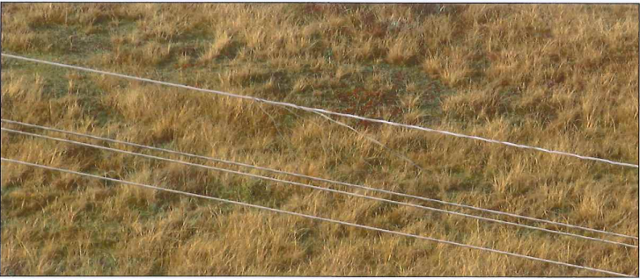

- Conductor anomaly discoloured: Tower span from 157 – 159.
Scope:
- Assess and report whether discoloration is due to overheating, corrosion, or surface contamination.
- If applicable, propose corrective measures.

- Spacer missing on Tower 46, On the Edwaleni Side.
Scope:
- Inspect and identify the required spacer.
- Supply and Install spacer damper as per line specifications.

- Bird Nest on Tower 98, 99, 241, 243,261,296 and 297.
Scope:
- Carry out Inspection and removal of active/inactive nest (in accordance with environmental regulations
- Supply and Install bird guards/diverters on affected towers to prevent recurrence as per NTCSA specifications.

EDWALENI MAPUTO LINE

- Insulator pulling: Tower 66 and 115.
Scope:
- Conduct close inspection of insulator strings at towers to confirm degree of “pulling”.
- Check associated hardware for deformation of looseness.
- Assess integrity of insulators, towers, fittings and report integrity and the need of further action to restore correct specification. If any action as re-align or tighten insulator strings, fittings need/be possible to do while contractor on site, contractor must report to client before contractor leave site.

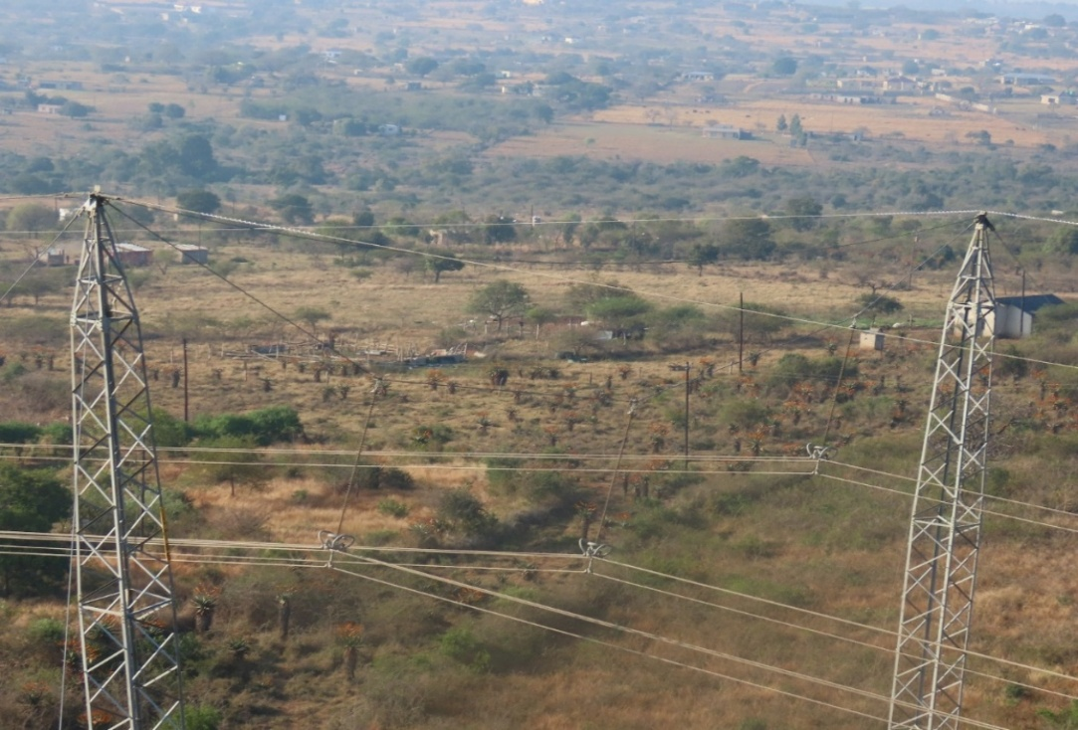

- Tower label broken: Tower 113.
Scope:
- Remove broken tower identification plate.
- Supply and install a new tower label as per standard specifications.

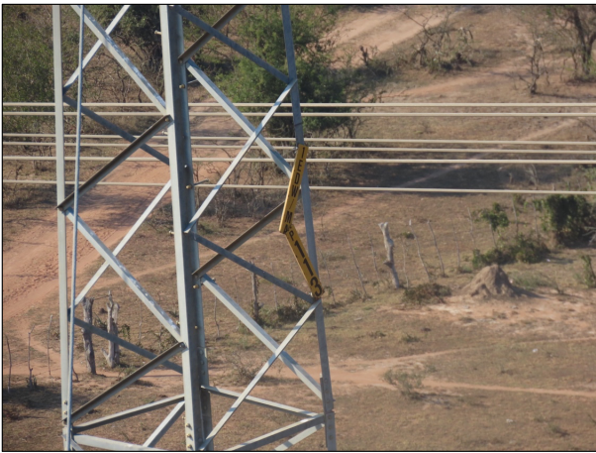

- Earth Wire Jumper broken: Tower 145, 169,170 and 179.
Scope:
- Inspect the earth wire jumper connections at the affected towers.
- Remove damaged jumpers and associated fittings.
- Supply and install new earth wire jumpers of the correct size and type, with proper compression fittings.

